THE FRANK SANTAROSSA SCHOLARSHIP FUND
SCHOLARSHIP APPLICATION

The Frank Santarossa Fund will provide financial assistance to players of the Greater Ontario Junior Hockey League, to assist them in their further education.

Greater Ontario Junior Hockey League

GUIDELINES:
- Academic success: Student should have attained a "B" or 70% grade average the previous year.
- Students can be either full or part time, and must be registered in a Canadian University or Community College for the upcoming season.
- Must have been a registered player on a GOJHL member team.
- Player must have played two years in the league and have competed in 60% of his teams games per annum.
- An application letter is required from his member team.
- An application letter is required from the player outlining reasons he should be awarded a scholarship
- A scholarship can be obtained for two years if selection committee so warrants.
- An application is required for second year scholarships.
- A player can obtain a scholarship and still be a registered player within the League.
- DECISION OF THE SELECTION COMMITTEE IS FINAL.

PAYMENT:
- To be made to the University or College at the beginning of the second semester.
- Applications must be received by no later than June 30 2020
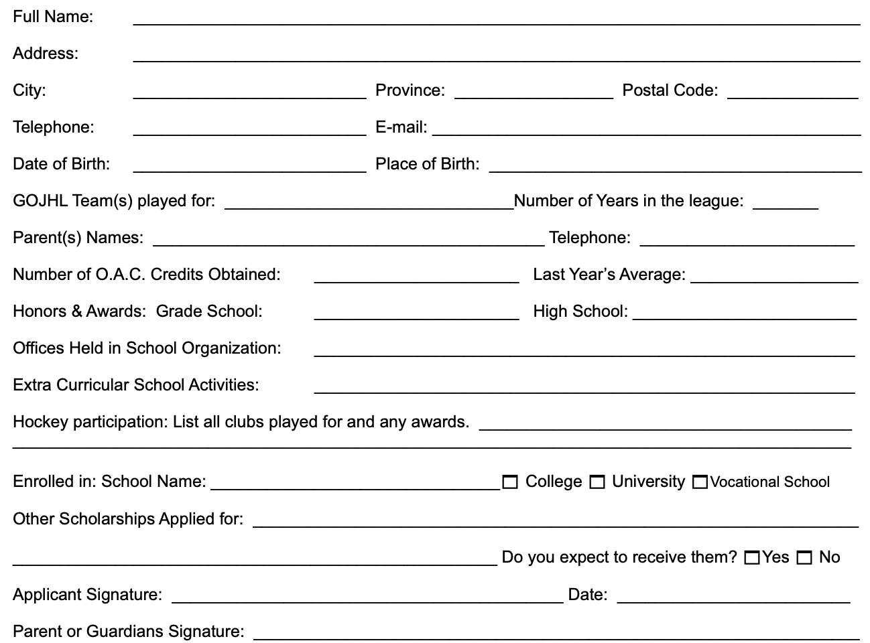

Please mail this completed application form and team application letter to:
Shawn McKelvie - 460A Belmont Ave West, Suite 105, Kitchener, ON N2M 0A9

